Exercise 12 : Implementation of Conditional Rendering in React using Login and Logout

Aim
To implement conditional rendering in React using Login and Logout buttons to display Guest and User pages.

Objectives
- To understand conditional rendering.
- To use element variables and state.
- To switch between Guest and User pages.
- To implement Login and Logout functionality.

Tools Required
- Node.js
- NPM
- React.js
- Visual Studio Code

Theory
1. Conditional Rendering in React
Definition
Conditional Rendering is a technique in React used to display different UI components based on a condition or application state.
Instead of always displaying the same content, React checks a condition and renders the appropriate component.
Why is it Needed?
- Display different pages for logged-in and guest users.
- Show or hide buttons, forms, and messages.
- Display loading indicators while data is being fetched.
- Handle errors and empty states.
Methods of Conditional Rendering
- if-else statement
- Element Variables
- Logical AND (&&) Operator
- Ternary Operator (condition ? true : false)
Advantages
- Improves user experience.
- Makes UI dynamic.
- Reduces unnecessary rendering.
- Simplifies component management.

2. Element Variables
Definition
An Element Variable is a JavaScript variable that stores a React element. It allows developers to decide which component or element should be rendered before returning JSX.
Why Use Element Variables?
- Makes code cleaner.
- Reduces nested conditions.
- Improves readability.
- Useful when rendering multiple components based on conditions.

Advantages
- Cleaner code.
- Better readability.
- Easy to maintain.
- Useful for complex conditions.

3. Preventing Components from Rendering
Definition
Sometimes a component does not need to display anything. React allows a component to stop rendering by returning null.
Returning null means the component exists but nothing is displayed on the screen.
Why Prevent Rendering?
- Hide unnecessary components.
- Improve application performance.
- Display components only when required.
- Avoid rendering invalid or empty data.
Advantages
- Reduces unnecessary rendering.
- Improves application performance.
- Makes UI dynamic.
- Provides better control over component visibility.

Procedure
- Create a new React application named ticketbookingapp.
- Create four components: GuestPage, UserPage, LoginButton, and LogoutButton.
- Implement GuestPage to display flight details.
- Implement UserPage to display booking details.
- Create Login and Logout buttons.
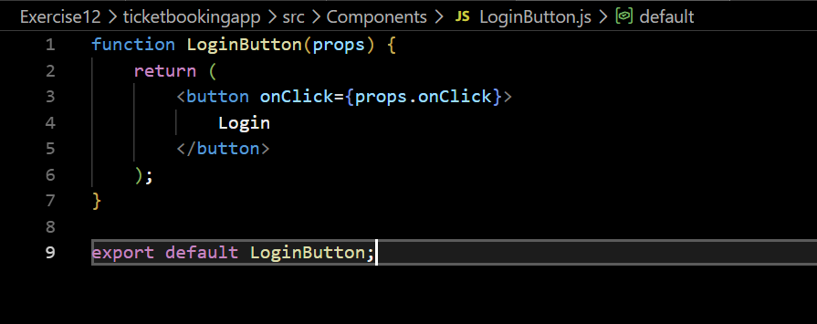
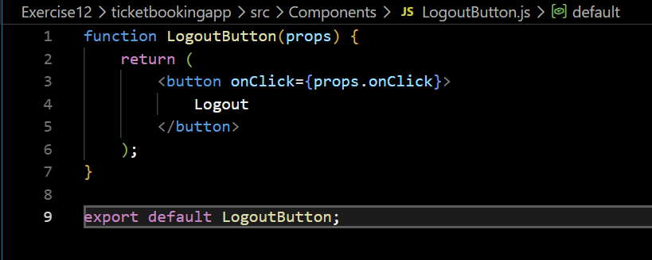
- Use the useState() hook to maintain the login status.
- Use conditional rendering to display GuestPage when the user is logged out and UserPage when the user is logged in.
- Run the application using npm start.
Result
The React application was successfully implemented using conditional rendering. The Guest page was displayed before login, and after clicking the Login button, the User page with booking options was displayed. Clicking Logout redirected the application back to the Guest page.

